What is R?

**20160530:23.00**

**The purpose of this module is to give you some background information about R, how and why it was developed, and what it is designed to do**

R is one of a number of stats packages such as:









But unlike some, it does not cost an arm and a leg

# Some background about R

R is a programming language and software environment for statistical computing and graphics supported by the R Foundation for Statistical Computing. See Wikipedia entry for more details [here](https://en.wikipedia.org/wiki/R_%28programming_language%29)

R is an implementation of the S programming language. S was created by John Chambers working at Bell Labs. R was created by Ross Ihaka and Robert Gentleman at the University of Auckland, New Zealand and is currently developed by the R Development Core Team of which Chambers is a member

R is a [GNU project](https://en.wikipedia.org/wiki/List_of_GNU_packages) – follow the link to find out more about what it means to be a GNU project

Since 1997: International R Development Core Team of around 15 people and 1000s of code writers happy to share their libraries

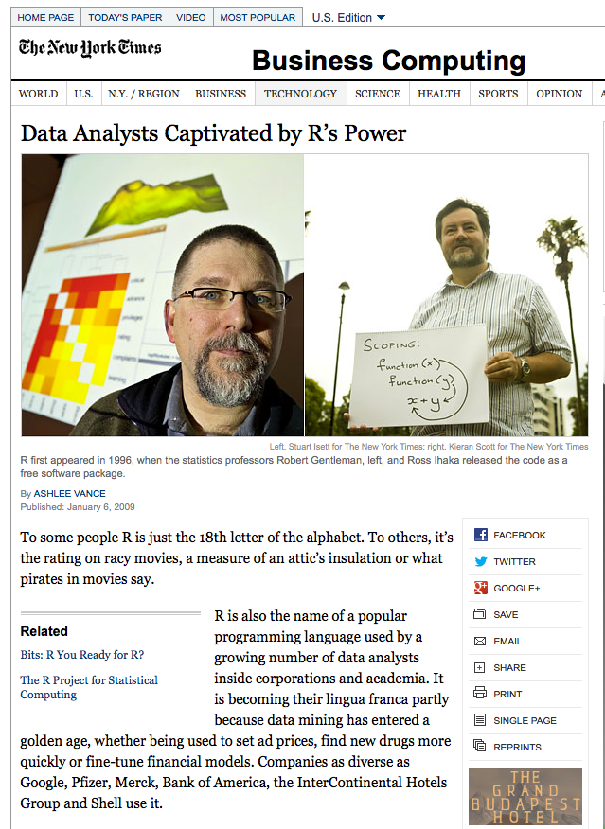

Some key features of R

* R is language and environment for statistical computing and graphics
* R is available as Free Software under the terms of the Free Software Foundation’s GNU General Public license
* An effective data handling and storage facility
* Suite of operators on arrays / matrices
* A large collection of intermediate tools for data processing, analysis, statistics
* Graphical facilities for on screen or printout
* Well developed programming language including conditionals and loops etc.
* An interpreted language accessed through a command line interpreter
* Highly extensible through user submitted packages / libraries
* Highly scalable

**R as a Graphical Information System**

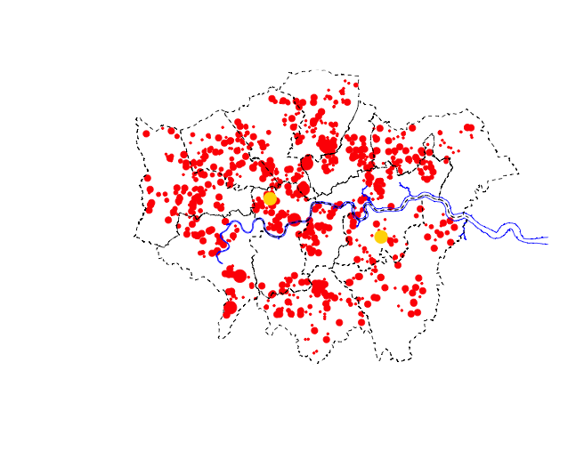

**Compartmental models in Epidemiology**

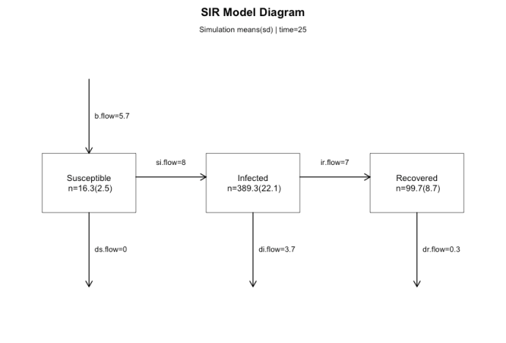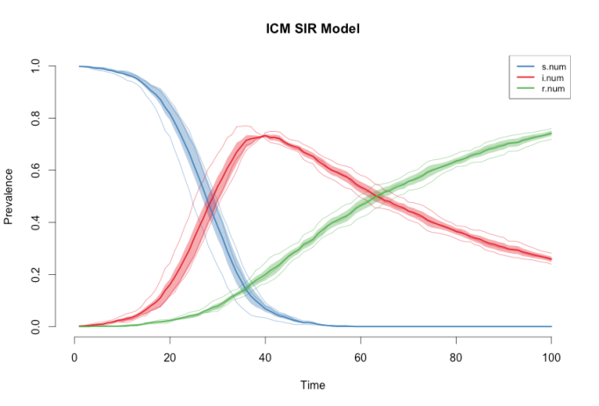

“Open Source”… that just means I don’t have to pay for it?

**No – it means so much more….**

* Provides full access to algorithms and their implementation
* Gives you the ability to fix bugs and extend software
* Provides a forum allowing researchers to explore and expand the methods used to analyse data
* Is the product of 1000s of leading experts in the fields that they know best
* Ensures that scientists around the world – and not just the ones in rich countries – are the co-owners to the software tools needed to carry out research
* Promotes reproducible research by providing open and accessible tools
* Most of R is written in R! This makes it quite easy to see what functions are actually doing

R in more detail

* R is an interpreted computer language.
  + Most user visible functions are written in R itself, calling on a smaller set of internal primitives
  + It is possible to interface procedures written in C, C+ or Fortran languages for efficiency, and to write further primitives
  + System commands can be called from within R
* R is used for data manipulation, statistics, and graphics. It is made up of:
  + Operators (+ - < * / % *%...) for calculations of arrays and matrices
  + Large, coherent, integrated collection of functions
  + Facilities for making unlimited types of publication quality graphics
  + User written functions and sets of functions; 800+ contributed packages so far and growing

Need a supercomputer?

**No you don’t**

* R is made for Cloud Computing
* Guide to use R in the Cloud  
  [Tore Opsahl](http://toreopsahl.com/2011/10/17/securely-using-r-and-rstudio-on-amazons-ec2/)  
  [R-bloggers and using R on Amazon EC2](http://www.r-bloggers.com/instructions-for-installing-using-r-on-amazon-ec2/)
* It is possible to rent a server with 16 cores and 1 TB of memory for $4 per hour

R web deployment

* Shiny
* Follow the link from [here, view the gallery – or even take the tutorial to build your own web apps](http://www.rstudio.com/shiny/)!
* But beware – it can get addictive

Some further WWW resources

[The R project for statistical computing](https://www.r-project.org/)

[Quick R Homepage](http://www.statmethods.net/)

[Try R code school](http://tryr.codeschool.com/levels/1/challenges/8) – interactive web site that very gently takes you through the basics of using R without first needing to install anything on your computer